Some Complexities

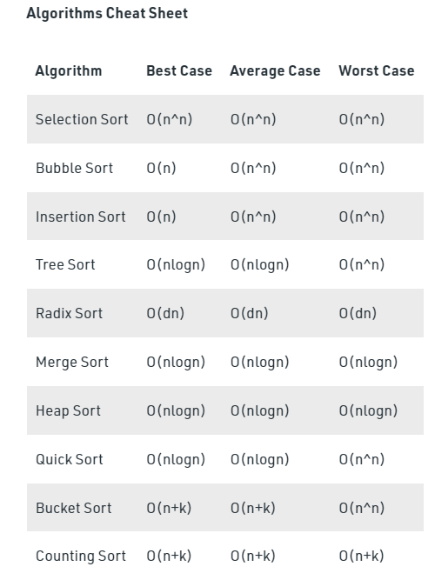

Recursion Tree



